Pumpkin Seed Pumpkin Fall Craft
This fun pumpkin craft is a definite kid favorite, especially in the preschool age range. Our almost three year old daughter loved this craft. Making a pumpkin out of painted pumpkin seeds is a perfect fall craft for preschoolers, and it's even a great way to use up some of the pumpkin seeds left over from carving night. At first glance, laying all 100 pumpkin seeds out on tape to be painted may look a little daunting, but we found that this was actually our daughter's favorite part as it fed right into that part of a preschoolers brain where they love to line things up! 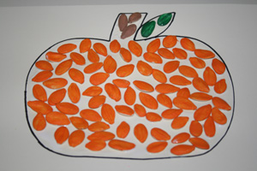
What you'll need:
- Lightweight cardboard (we cut up an empty cereal box)
- Pumpkin printable template
- Painters or masking tape
- Paint brush
- Black marker
- White glue
- Orange, green and brown paint
- Newspaper (to cover the painting surface)
- 100 dried pumpkin seeds (a small bag will be more than enough). If you are using seeds that aren't store bought, make sure to roast them first to dry them out, otherwise the paint will never stick!
How to make your Pumpkin Seed Pumpkin Craft:
- Cover your craft area with newspaper. Make giant tape donuts and stick them down to the newspaper. Lay the pupmkin seeds out in a row on the tape. This is the easiest way to have your child paint the seeds - otherwise it's quite a bit messy! You need about 100 seeds total (this is enough to give you a bit extra).
- Paint the seeds. You need 2 seeds painted green (for the leaf), 4 seeds painted brown (for the stem) and the rest painted orange.
- While the paint dries, print out the pumpkin template. Cut the pumpkin out and trace it onto a lightweight sheet of cardboard.
- Squeeze white glue onto the pumpkin drawing and spread it around with your finger to make an even layer.
- Place the seeds, painted side up, onto glue to create your pumpkin!

