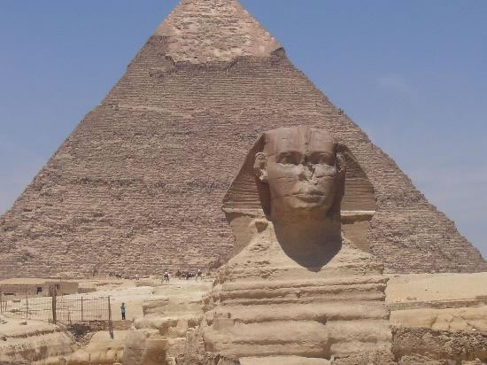



The Pyramids of Egypt were built during 2700-2500 B.C in Giza on the west bank of the Nile and are the most ancient of the Wonders of the World. The first three of the ten pyramids at Giza are considered to be the most important. The first pyramid is the largest and is known as the Great Pyramid. It was built for Pharaoh Khufu, also known as Cheops, and is 450 feet high.

Interesting facts

Some believe that the Cheops Pyramid was built by slaves but this is not true. One hundred thousand people worked on it for three months of each year. This was the time of the Nile's annual flood which made it impossible to farm the land and most of the population was unemployed. He provided good food and clothing for his workers and was kindly remembered in folk tales for many centuries.

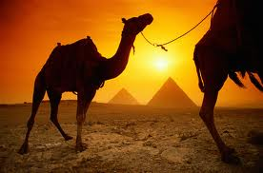

Questions:

1. When were the Pyramids built?

2. Where are they situated?

3.Which pharaoh built the largest pyramid?

4. Did the slaves take part in the construc-tion of the pyramids?

5. Which pyramid is the largest construc-tion in the world?

6. How are the sides of the pyramids oriented?

7. How much does an average limestone block weigh?

Limestone blocks weigh on average 2.5 tons each. But some weigh as much as 16 tons.

The Cheops Pyramid was constructed using around 2,300,000 limestone blocks.

The sides are oriented to the four cardinal points of the compass

There are three great pyramids at Giza, each of which once had an adjoining mortuary temple.

The 'great' pyramid itself is truly an astonishing work of engineering skill - for over four thousands years, until the modern era, it was the tallest building in the world.