

Cycling



Golf



Ice skating

Fencing



Hurdles

Horse riding

Relay

Weight lifting



Ice skating

Skiing

Skateboarding

Sailing



Hoops

Ribbons

Target practice



Diving



Table tennis

Parachuting

Canoeing

Climbing



Skiing

Tennis

Judo



Handball



Water polo

Volleyball

Javelin throw

Football



Hockey

Hang gliding

Discus throw

Bowling



Baseball

Basketball

Badminton

Karate



Sky diving

Windsurf

Motocross

Archery

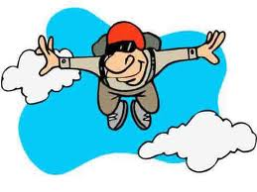

Swimming



Surf

Boxing

Bungee jumping

